Gregory Fox

Professor Rivas

CMPT 440

5 May 2016

Project Milestone 2 Documentation

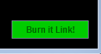 My editor puts sees if your text runs IN THE MATRIX. Not actually in the matrix, but in my DFA matrix. The text editor can run simple programs that you create in the editor. It has one main button that is a direct quote from the movie the matrix, "Burn it Link".

Within the window there is also a box to enter text, along with the title.

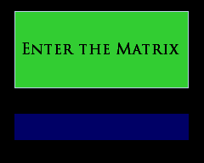

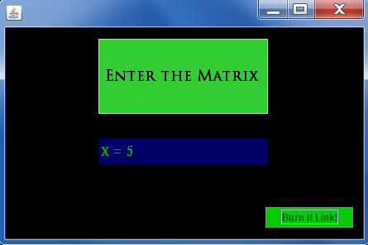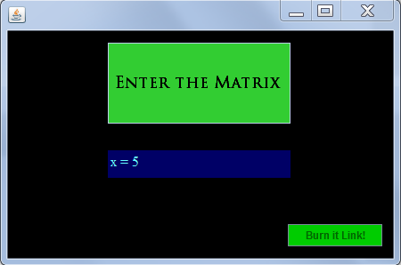The text in my program will change based on whether it runs correctly or not. If the input runs correctly, both the font and the color will change!

If the input does not run correctly, then it will change the color and font in a different way!

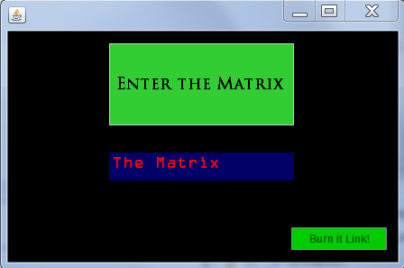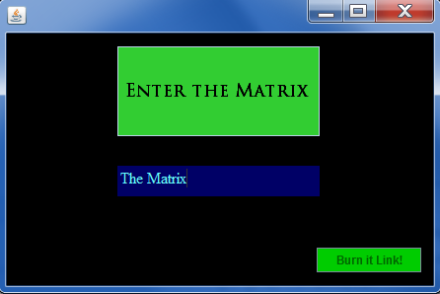

Hopefully it works well! and Hopefully you're the one!